**CASE STUDY-1**

**Create multiple instances with different names using variable block**

**STEP-1: CREATE AN EC-2 INSTANCE**

**STEP-2: CONNECT TO THE INSTANCE**

* Connect the instance by the following commands

# sudo –i

# apt upadate –y

# apt install unzip –y

* Install amazon CLI

# curl "https://awscli.amazonaws.com/awscli-exe-linux-x86_64.zip" -o "awscliv2.zip"

unzip awscliv2.zip

sudo ./aws/install

* Install terraform

# wget -O- https://apt.releases.hashicorp.com/gpg | sudo gpg --dearmor -o /usr/share/keyrings/hashicorp-archive-keyring.gpg

echo "deb [signed-by=/usr/share/keyrings/hashicorp-archive-keyring.gpg] https://apt.releases.hashicorp.com $(lsb_release –cs

) main" | sudo tee /etc/apt/sources.list.d/hashicorp.list

sudo apt update && sudo apt install terraform

**STEP-3: GO TO IAM**

* Go to users
* Click on create user
* Give user name and Click on next
* Select “attach policies directly” select “administrator access”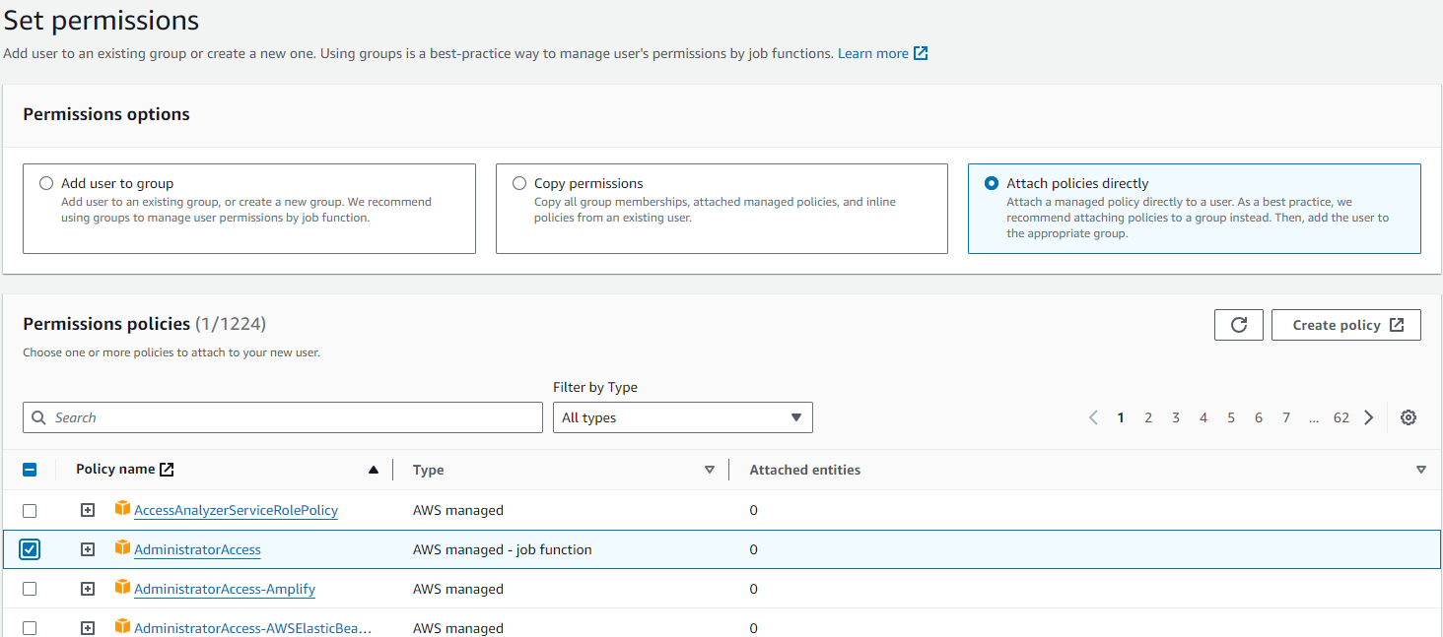
* Click on next
* Click on Create user
* Select the user
* Click on Create Access key
* Select the “Command Line Interface (CLI)”
* Click on Next and Click on Create Access key
* Copy the Access key and Secret Access key

**STEP-4: GO TO SERVER**

* Type the commands

# aws configure

# paste the access key

# paste secret access key

# choose the region

# choose the output format

* Create terraform directory

# mkdir terraform

* Go to the directory

# cd terraform

* Create terraformblock

# vi terraformblock.tf

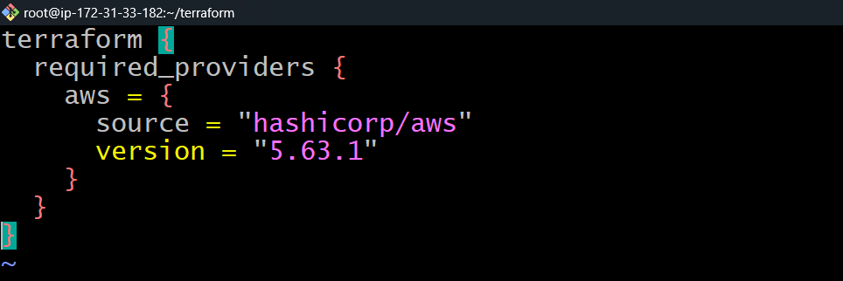

* Create providerblock

# vi providerblock.tf

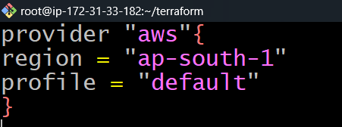

* Create variableblock

# vi variableblock.tf

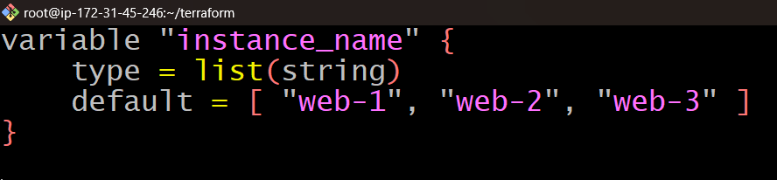

* Create resourseblock

# vi resourseblock.tf

* Paste the code in resourseblock

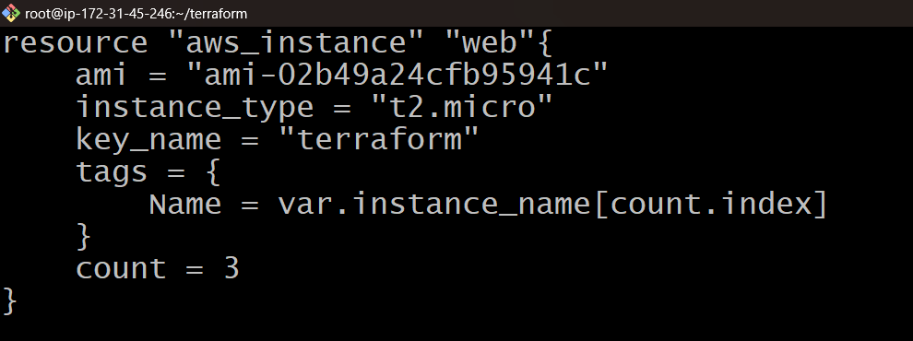

## STEP-5: Running Terraform commands to Launch multiple AWS EC2 instances.

After creating the block perform the terraform commands to launch the instances.

# terraform init

# terraform validate

# terraform plan

# terraform apply

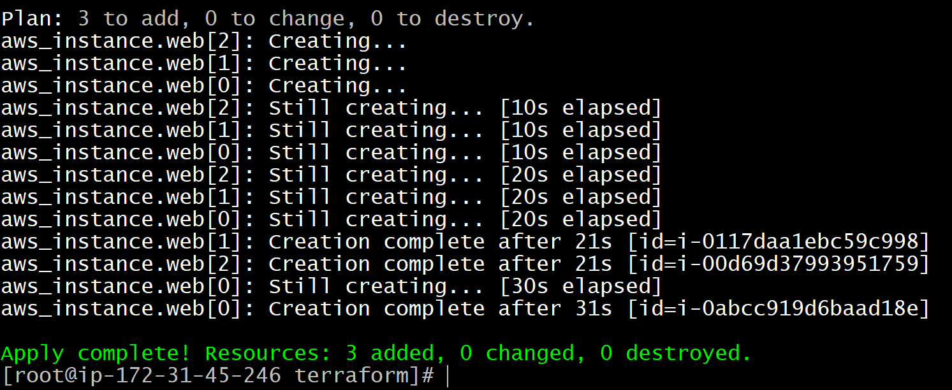

After performing the command, go to the AWS console check the instances are created.

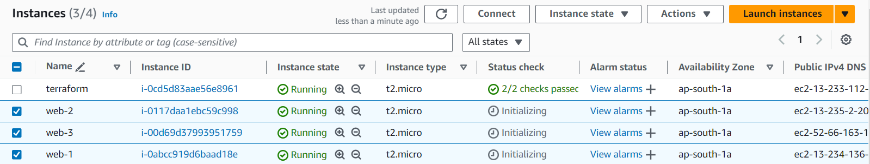

After performing the operations destroy the applications that you created using terraform, by applying the command.

# terraform destroy

